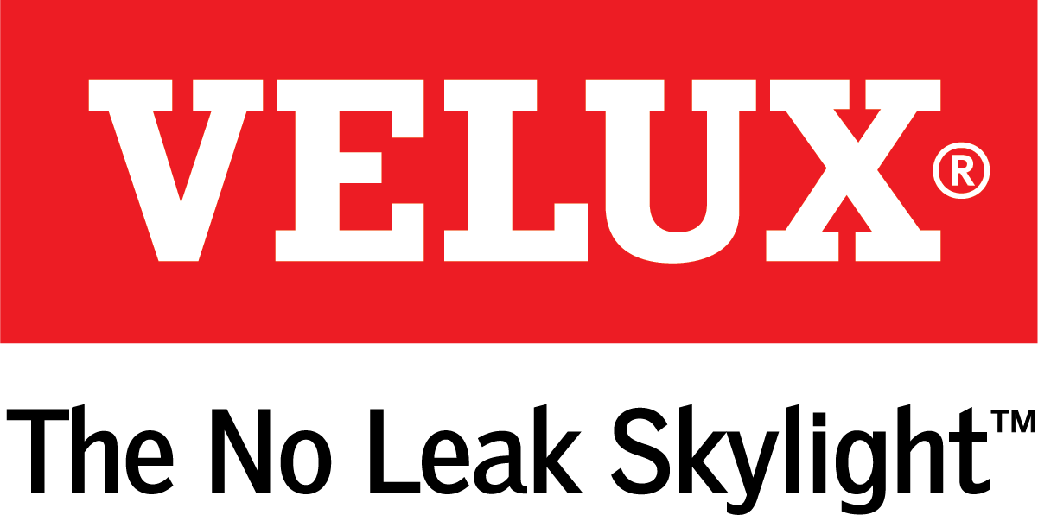
Media Contacts:
Kelsey Webb
704-790-1560
kwebb@wrayward.com

Dana Haydock
704-926-1301
dhaydock@wrayward.com

WASCO RESIDENTIAL OFFERINGS NOW AVAILABLE THROUGH VELUX
Extended Line Offers Large-Span Skylights and Creative Customizations

LAS VEGAS, Feb. 19-21, 2019 – When VELUX America acquired Wasco Products Inc. last spring, it created a one-stop shop for any residential daylighting need, from large-span skylights and No Leak solar powered skylights to architectural skylights and Sun Tunnels.
Wasco, part of the VELUX Group, brings two versatile residential products that allow for larger skylight spans and creative skylight configurations to the newly combined company, and both can be viewed in the VELUX IBS booth C3307.
SkyMax Large Span Skylights offer single light space up to 32 square feet measuring ten feet at the longest dimension. This option also doubles the square footage of a standard size flat glass skylight without the loss of thermal efficiency. The SkyMax, which comes with a 10-year warranty, is custom ordered and boasts no condensation or weep holes.
The Architectural Series allows architects and custom builders to design the home’s framing to meet their vision for the skylight, whether it’s a grand atrium, a vaulted staircase or a luxury pool house. This customizable skylight comes in an extensive line of configurations, finish colors and glazing options with runs up to 40 feet wide with unlimited length available. For flat roofs, choose from square, octagonal and extended pyramid options, and for pitched roofs, choose from single and double pitch, low profile and structural ridge.
“With these additions we make it possible to bring any daylighting vision to life,” said Ross Vandermark, national product manager for VELUX America. “Our expanded residential product line gives builders and their customers more options that are both easy to install and customizable.”
For more information on the VELUX acquisition of Wasco, please visit veluxusa.com/media/press-kits/wasco.

# # #

VELUX is the world leader in skylights and roof windows and is one of the strongest brands in the global building materials sector. VELUX America products are available nationwide through home centers, building material suppliers, lumberyards and independent door, window or roofing retailers. Consumers can locate local suppliers and installers and access information on skylight selection and the benefits of bringing more natural light and fresh air into the home by visiting www.veluxusa.com or www.whyskylights.com. VELUX skylights are made in America in Greenwood, South Carolina.

